Selling Parish Council

Action for Insects

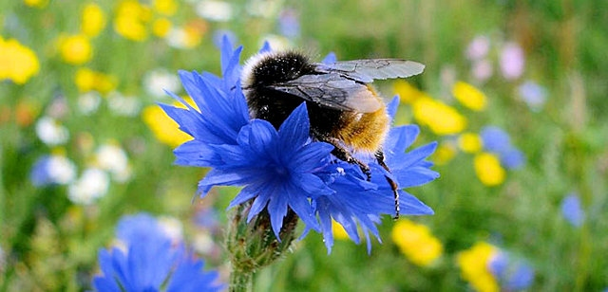
Where are we now?
Insects and pollinators are a critical part of our ecosystems. Today 41% of insect species face extinction in England. UK butterfly populations are down more than 50% since 1976 and we have lost 97% of our wildflower meadows since the 1930s. The loss and degradation of habitats is the most significant cause of pollinator decline. Many wildflower-rich habitats are now small areas separated by land uses hostile to insect pollinators, making it difficult for insects to move around our landscapes.
More and better-quality wild spaces for insects will significantly contribute to our biodiversity - the full range of life found in a geographical area that includes visible life such as vegetation and animals, through to the invertebrates in the soil, mosses, fungi, and even life we can't see. Pollinators are insects which are essential to our environment, and even to our lives. We need them because they carry the reproductive dust, pollen, from flower to flower to grow the new generations of plants.
Perhaps the best loved of pollinators are bees, among which are honeybees. These are the only pollinators kept by humans. Wild pollinators include bumblebees and solitary bees but also parasitic wasps, hoverflies, butterflies, moths, mosquitos, some beetles and even ants in small way. Sadly, they are also declining fast.
Despite the serious decline, insects including pollinators can recover. Action at local level can be key to reversing this. Selling is fortunate to have already had some fantastic local initiatives and skilled people who have made a difference in supporting our bees, other pollinators and insects. We want to take this further and in a bigger context.
What do we want to do?

Our own individual garden space is where most of us can help insects and pollinators quickly and effectively. That could be through planned planting of insect and pollinator friendly flowers on any scale from a lovely window box to more sophisticated outdoor space. We could also just let wildflowers do their own thing and run free, even in lawns.

In public areas in Selling, we want to involve the whole village to:
- identify unused, unloved or ignored spaces that we could all transform into thriving insect and pollinator friendly environments
- create a map of these spaces across the village and share with residents
- encourage ownership and care of these specific areas by individuals or groups - whether informal or formal
- find ways to create corridors for wildlife throughout the Selling landscape
- support the connection of landscapes to each other and share these with, Swale Borough Council and Kent County Council to create a three-tier layer of support for our insects
- keep residents of Selling and visitors informed of what we are doing and why verges have not been cut through signage, our website, social media, press, meetings, and word of mouth
- support initiatives and local action through our Parish Council community grants and other sources of funding

Let’s work together
Kent Wildlife Trust (KWT) is actively promoting and supporting the national Wildlife Trust campaign Action for Insects and has invited Selling Parish Council to come up with a plan of activity. By doing so, we are also contributing to Swale Borough Council's ambitious Biodiversity Action Plan - which is intended to provide a sound basis for local action to conserve, protect and enhance the biodiversity of the Borough. We are also now connected and working together with Kent County Council’s excellent Plan Bee, which shares our objectives to transform the landscape into pollinator friendly joined spaces.
We obviously want all those in the village who are interested to join together in this long-term project. We are still only in the early stages of Action for Insects. All ideas and suggestions are very much welcomed. Our plan is on our website sellingparishcouncil.gov.uk and we welcome your feedback and ideas to make it better.

The role of the Parish Council is to work for the benefit of all residents of Selling. We will co-ordinate, manage resources and risk, and reach out to key partners and stakeholders such as Kent Wildlife Trust, KCC, Highways and Swale Borough Council. We have already arranged necessary insurance cover for outdoor activity and will be obtaining cultivation licences from KCC for identified areas we all want to make into wildflower spaces for the benefit of insects. We will also ensure there is proper risk assessment of activity where required. We have our own community grants available and strongly encourage applications via our Clerk. Please visit our website to find out more.
The Autumn Plan
Phase 1 Buy-in. To make people aware that we all care, and to stimulate interest. It is not just about the public areas of the village - what we can all do in our own spaces at home is equally important.
Phase 2 Mapping. We have invited everyone to help identify those areas across Selling where we want to take action for insects and wildflowers. We are mapping those areas and will publish the results to get further interest and involvement. Mapping our wild areas will also help us to explore how we can establish insect & pollination corridors and get synergy with Swale Borough Council and Kent. County Council. It also directly supports our Highways Plan priorities for a potential 30 mph speed limit and traffic calming by improving the visual environment for road users. This is when we can obtain cultivation licences.
Phase 3 Ownership. To promote 'ownership' of certain areas by those who live closest or have an interest and to encourage them and support their activity. This will be evidence-based using the mapping and an agreed collective way forward involving all interested individuals and groups (whether formally constituted, informal or social).

Phase 4 The right seeds & bulbs. Identify and supply the appropriate seeds, bulbs and grass cutting necessary for a successful Spring and Summer flowering. To do this we will work closely with Kent Wildlife Trust and their sources of expertise as well as local knowledge and wishes. Our community grants will enable individuals and groups to buy their own seeds and bulbs.

Phase 5 Planting. Harness the energy, hard work and know-how of Selling people and other willing helpers to get our ambitious plans under way together.

What else can we do during these challenging times?

Ensuring access to wild and green space has proven positive social and economic benefits - including physical health, mental well-being and quality of life. We can all do with these attributes during the time of the pandemic and this whole Action for Insects plan offers an inclusive village-wide focus for the whole community on a tangible project. Anyone and everyone can freely contribute. We can all support and look out for each other.
Our Parish Council website sellingparishcouncil.gov.uk is required and mandated by law. We don’t do WhatsApp gossip, untruths and misinformation. As an important tier of government and closest to our communities, what we do is relevant, factual information for the benefit, health and well-being of all residents of Selling. We are an integral part of the gov.uk online community, offering a central point of authoritative information drawn only from key government sources. You can also find information on our Sellingparishcouncil Facebook page. We delivered a variety of newsletters and posters to every household in the village earlier this year and may do the same again and always in the prescribed safe, socially distanced conditions. Please free to engage and contact us online - or of course by phone, letter or by personal (safe) contact with any councillor.

We can all help reverse insect declines in local areas. Whether individually, as a formal or informal group, in public spaces or at home, there is always something we can do.
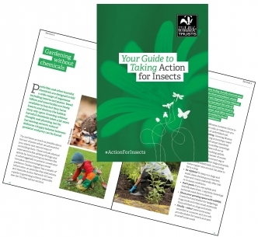
Kent Wildlife Trust is actively promoting and supporting the national Wildlife Trust campaign Action for Insects. Get your free Guide to Taking Action For Insects at: www.kentwildlifetrust.org.uk/action-insects
Top tips from Kent Wildlife Trust
- Wherever possible, plant native species that are locally sourced or grown and try to create and connect a variety of habitats – the right ones for where we live
- If creating a meadow or tree planting, try to use UK-sourced seeds and plants wherever possible. Imported seeds, plants and animals can accidentally bring diseases into the country
- Try to blend habitats in the community together rather than creating sharp boundaries between them. These blended edges are vital for many species
- Think about ‘structural diversity’ when creating, enhancing or connecting habitat. In most habitats, a mix of foliage heights is best for wildlife
How does a cultivation licence help Action for Insects?

It means we can identify road verges, banks and other areas of public land maintained by Highways and take control through obtaining a cultivation licence. KCC will not cut the grass or trim on an area that has a cultivation licence. You need significant indemnity insurance, which the Parish Council has now secured. We will be able to plant low level shrubs and wild flowers to establish an insect-friendly environment and create wildflower meadows.

Costs

The principle behind this plan is that it is very low cost. Non-intervention practices - such as allowing wildflowers to grow alongside paths, on greens and in the churchyard – are cost free.

Positive interventions, such as planting of bulbs and seeds, would mean buying materials - mostly at low cost dependent on scale. Each cultivation licence is free and there is no restriction to the number we can hold.

